**Assignment – 4**

**International Dataset Interaction with Tableau**

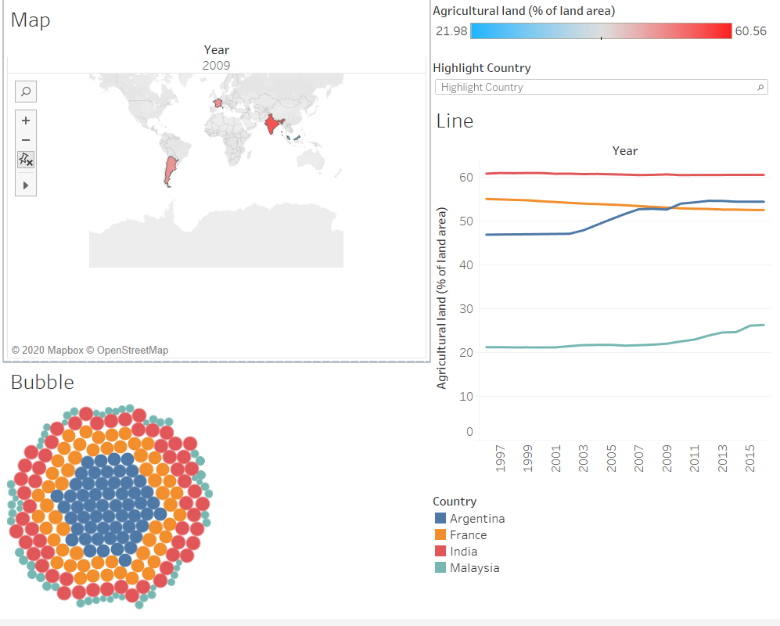**Four Countries:**

1. Low-Income Economies: Malaysia
2. Lower Middle Income Economies: France
3. Upper Middle Income Economies: Argentina
4. High Income: India

**Selected Indicator: Agricultural Land (% of Land Area)**

**Comparison Analysis:** The countries mentioned in the analysis are Argentina, Malaysia, France, and India. The indicator, I have taken under the consideration is Agricultural land (% of Land Area) covered by the country on the earth. The line plot defines the percentage from 0-60% of land covered by the country for Agriculture. Argentina has shown really good growth in developing agricultural land. The interesting thing found in the comparisons is the flow to increase and decrease in the agricultural field of each country. As agricultural land is based on several factors like rain per year, the weather suitable for land and also the material required for the farmers to take under consideration. Tableau is one of the best tools for interactive analysis purposes, there is nothing that you cant describe while using tableau. I have done little projects on IBM Cognos Insight, but it is hard to use with its features. The tableau is easy to use and very much adaptive.

**Tableau Interactive Capabilities Reflection:**  The Tableau was very fun to operate, its like tableau says the get me more data and I will you visualize it. One feature that was really interesting to use was the map feature in which the countries get different colors based on the percentage of the land of the particular year. For eg: in the snapshot, I compared the different cities' land proportions and for the year 2013. The bubble plot is helpful to analyze a large cluster of different countries with data representation. The other usage is that filters help you to analyze the data based on the required year and removes null values.